**Get Request methods with Paremeters:**

After opening the Request it shows a URL field where we can paste the url and get the information.

I pasted the below link and after send the request I got the output as below.

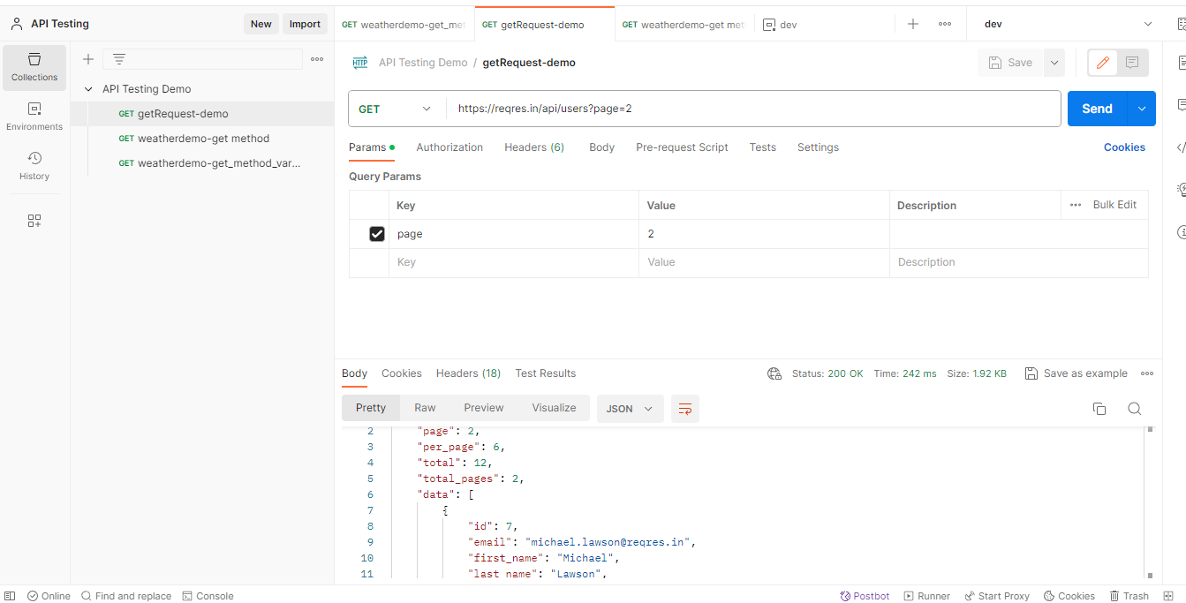

If we get 200 as status means the request and response both are valid.

**Get method:**

For this Scenario Iam going to use the API for this Iam using the Weather Api ,for that go to the below link for API key generation and to use we need to signup with the website with valid credentials.

<https://openweathermap.org/api>

After login to the page we can see

Now create api keys - go to your account- click on my Api keys

There Is option for generate API keys we can provide name and click generate it will generate the API key we can use that key to access the page.

Next go to the API option in page and selected the below one

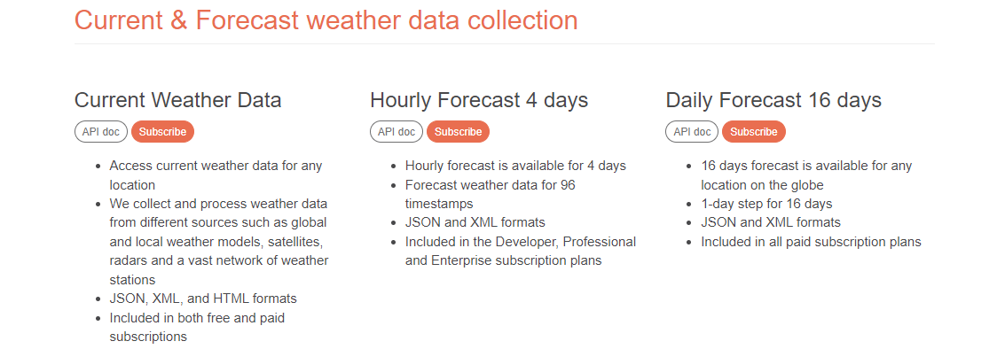

In current weather I selected the Api doc and open the below page

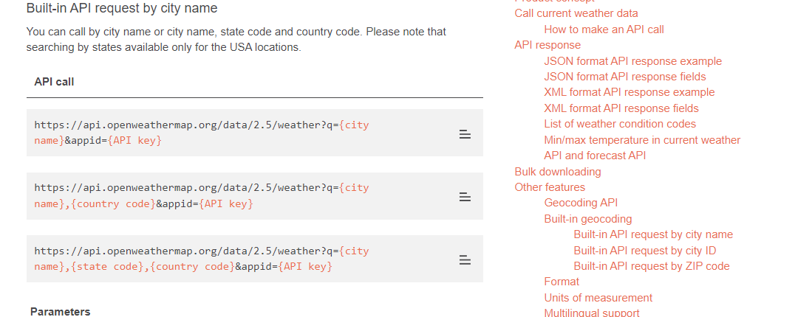

I taken the First key and need pasted my API key in that

https://api.openweathermap.org/data/2.5/weather?q={city name}&appid={API key}

Now open request and paste the API with key And send request and I got as below.

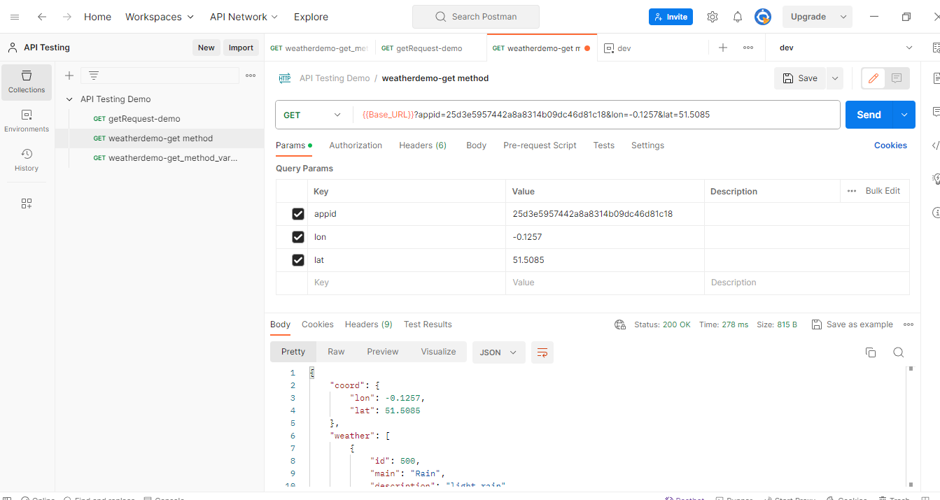

AS above we can pass the Keys and it generates the result.